*M.E.H*

*Time of the activity: 7:00pm Date of the activity: Wed 9th of October.*

*Usability testing*

Name of the participant: Lily Henson

**Facilitatory help notes:** Give them the task, but do not tell them how to complete it. Ask them to talk out loud while they do it. Did they complete the task? Did they need help? Explain where they needed help? How long did it take for them to complete that task?, What was the error rate (0 – no errors, 5 a lot of errors), this allows us to communicate through quantitative data. Explain why and where those errors occurred. Similar process to success rate (0 – no success – 5 great success) – success can be measured on errors, but more so on confusion and how easy it was. User satisfaction (0 poor – 5 great) comment on when, where, why and how. General comments about the task, more so about body language, and think aloud comments. After testing is complete gather themes and insights, and personal solutions you or the individual believes would be appropriate.

Application:

Task: Using the visual representation, set up an account.

|  |  |
| --- | --- |
| Could they complete the task? | YES / NO (circle)  Comment: |
| Did they need help? | YES / NO (circle)  Comment: |
| Time | 5 secs |
| Error rate | ( 0 – 1 – 2 – 3 – 4 – 5) |
| Error comments | Confused by platform |
| Success rate | ( 0 – 1 – 2 – 3 – 4 – 5) |
| Success comments | Use was successful. |
| User satisfaction | ( 0 – 1 – 2 – 3 – 4 – 5)  Comments: Confused on what Platform meant |
| General comments | Don’t know what the platform means |
| Common themes and insights | Clarity of information |
| Suggested solutions | Explain the platform things |

Task: So you have the application – set up the Bluetooth from the visual representation. (Connect to the wearable)

|  |  |
| --- | --- |
| Could they complete the task? | YES / NO (circle)  Comment: |
| Did they need help? | YES / NO (circle)  Comment: |
| Time | 4 secs |
| Error rate | ( 0 – 1 – 2 – 3 – 4 – 5) |
| Error comments | No Errors |
| Success rate | ( 0 – 1 – 2 – 3 – 4 – 5) |
| Success comments | All completed well |
| User satisfaction | ( 0 – 1 – 2 – 3 – 4 – 5)  Comments: |
| General comments | Why does Bluetooth work if theyre separated. Wearable will be used when the device is not in Bluetooth distance   * Make more clear in setup that the connection is only for setup to get the wearable on the same account as the phone |
| Common themes and insights | Confusing- why do we need Bluetooth if they devices are separate? |
| Suggested solutions | Just make it more clear that the person doesn’t need to just follow you around when you are gambling. |

Task: Using the visual representation – transfer money to the wearable.

|  |  |
| --- | --- |
| Could they complete the task? | YES / NO (circle)  Comment: |
| Did they need help? | YES / NO (circle)  Comment: |
| Time | 10 secs |
| Error rate | ( 0 – 1 – 2 – 3 – 4 – 5) |
| Error comments |  |
| Success rate | ( 0 – 1 – 2 – 3 – 4 – 5) |
| Success comments | Easy process- needed solution (see comments) |
| User satisfaction | ( 0 – 1 – 2 – 3 – 4 – 5)  Comments:Only flaw was she was surprised at the amount she put on. |
| General comments | Didn’t know how much money they were transferring on- should be able to see more clear on how much money they are transferring. |
| Common themes and insights | Clearer diction on how much money |
| Suggested solutions | Screen for an option on how much to transfer onto the device. Make another screen after card details for that |

Task: From the visual representation, was is the activity on the Com-it wearable.

|  |  |
| --- | --- |
| Could they complete the task? | YES / NO (circle) |
| Did they need help? | YES / NO (circle) |
| Time | 2 seconds |
| Error rate | ( 0 – 1 – 2 – 3 – 4 – 5) |
| Error comments | No errors |
| Success rate | ( 0 – 1 – 2 – 3 – 4 – 5) |
| Success comments | Interface was easy to use and user was happy with the experience |
| User satisfaction | ( 0 – 1 – 2 – 3 – 4 – 5)  Comments: See comments, funcitionality was questionable; why does she give the money to thee gambler |
| General comments | Getting to activities page went well – smooth.  Why incentivise people to use this product? Cant they just steal from family and keep gambling without them knowing.  Why would family give money to gamblers? – Should gamblers put their own money on, then family putting |
| Common themes and insights | Shows how much they are spending, its good as it creates that conversation between family and gambler. |
| Suggested solutions | Put dates on the activity – you can track historical data then, then users can search specific days and see “last Wednesday you spent all 200$ on one day” as an example |

Task: Using the visual representation, try and send a text to the com-it wearable using the application.

|  |  |
| --- | --- |
| Could they complete the task? | YES / NO (circle) |
| Did they need help? | YES / NO (circle) |
| Time | 3 secs |
| Error rate | ( 0 – 1 – 2 – 3 – 4 – 5) |
| Error comments | No Errors |
| Success rate | ( 0 – 1 – 2 – 3 – 4 – 5) |
| Success comments | All successful, was easy to use |
| User satisfaction | ( 0 – 1 – 2 – 3 – 4 – 5)  Comments: |
| General comments | Easy to use  Good for gamblers. Really get them to think about their family and how they are spending their family |
| Common themes and insights | Family communication is good but will need to be monitored |
| Suggested solutions | Would family have suggestions on what to type? Shouldn’t they have suggestions on what to say- this is so they can say anything that could ruin relationships and fuel the fire |

Task: Imagine you want to problematic gambler to reduce their limit over time, the application allows for that – try and reduce the com-it level (hint – it’s in settings)

|  |  |
| --- | --- |
| Could they complete the task? | YES / NO (circle)  Comment: |
| Did they need help? | YES / NO (circle)  Comment: Was stuck on the name of the settings in the limit section; what do they mean? User was confused due to the terminology |
| Time | 10secs |
| Error rate | ( 0 – 1 – 2 – 3 – 4 – 5) |
| Error comments | Settings were not clear, needed guidance on finding the specific area for settings. U |
| Success rate | ( 0 – 1 – 2 – 3 – 4 – 5) |
| Success comments |  |
| User satisfaction | ( 0 – 1 – 2 – 3 – 4 – 5)  Comments: Bit confused. Knew that the limits section was a good idea, but the functionality of the settings was questionable. |
| General comments | Confused – why does the family have to put their own limit on. Is this the transfer limit between gambler or family.  Can you adjust the transfer limit. What is the point if I cant adjust  I think the limits will work really well. Can they spend all the money on one night? |
| Common themes and insights | Why does the family have to limit themselves; is this not just about the gambler |
| Suggested solutions | Make it more clear that one setting is for the family (if we do) and the other is for the gambler.  Make the distinction clear that youre imposing limits that can also be tapered off for the gambler |

Task: From the visual representation – how long is it until you are allowed to send money again?

|  |  |
| --- | --- |
| Could they complete the task? | YES / NO (circle) |
| Did they need help? | YES / NO (circle) |
| Time | 1 sec |
| Error rate | ( 0 – 1 – 2 – 3 – 4 – 5) |
| Error comments | No errors |
| Success rate | ( 0 – 1 – 2 – 3 – 4 – 5) |
| Success comments | Was very happy, successful and readability was good. |
| User satisfaction | ( 0 – 1 – 2 – 3 – 4 – 5)  Comments: See success comments |
| General comments | The lock makes sense. Make it just a bit clearer that the family and the gambler cannot function when the device is locked. |
| Common themes and insights | Lock feature works well- make the functionality a little clearer though |
| Suggested solutions | Maybe make it mutally known that the family simply cannot transfer, its out of their control so that the anger of the gambler can be contained. |

WEARABLE: NIL

Post testing survey based of criteria and concept viability.

|  |  |  |
| --- | --- | --- |
| CRITERIA | YES/NO | WHY and WHAT DO YOU THINK ABOUT THAT? |
| Does the product deter problematic behaviour? | Yes | The comm-it provides a family aspect to problem gambling. It would also prevent problem gamblers from spending money on gambling, whilst also working to manage addiction. |
| Does the product reduce stress? | Yes | The product reduces stress for the family as it allows them to track their spending, as well as provide an input into their road to recovery. |
| Does this product empower you to re-evaluate their choices? | Yes | Since problem gamblers often want family help in their recovery, the comm-it allows for this connection that allows them to play an important role in recovery while still allowing the gambler to make their own choices in their recovery |
| Does the product allow for a personalised experience? | Yes a tad no a tad | While this product provides a personalised experience through allowing family members to contact the gambler indirectly, it does not provide the emotional and mental support that the gambler would require to overcome addiction.  End of the day; app cant do this. Emotional support can only be given in person. Maybe put in some phone numbers that they can reach out to if they want to go treatment. App end of the day can’t help emotionally, but the numbers can supplement it to get them into treatment |
| Does the product educate you on problematic behaviour? | Yes | The product allows a family member to visualise the gamblers actions and spending patterns. This would provide the first steps into taking necessary and realistically achievable actions. |
| Does this product inform you on your lack of control? | Yes | Educates the user on spending patterns and trends, thus allowing the family member to control this through setting spending limits |
| Is this product easy to use | Yes | The usability was very straightforward and easy to navigate |
| Does this product allow gamblers to identify when they have a problem? | No | I believe that this product would only be used after the gambler has identified their problem and has decided to seek help. |
| Would you use this product to minimise gambling related harm? | Yes | This product would be very useful in allowing to control the actions of a problem gambler and ultimately ease them into the journey of recovery. |
| Do you believe this product is viable? Would you ever contemplate use it? | Yes with a BUT | This product is very helpful in allowing the family of the gambler to play a role in recognising their addiction and helping with management, however it does not provide the emotional support that the gambler would need at the time. An app can never provide emotional support, but treatment services and knowledge of treatment services can |

**Added concept solution area based on testing:**

* All the interface worked well, just some added features that would not go astray.
* Look into the solution space of shared income, may make more sense to have the money coming from a shared pool between the family and gambler.
  + Doesn’t make sense for the family to waste their money on gambling; do a shared income, or the gambler puts a certain amount of money in.
* May have to monitor the messaging service, some people gamble because their families are abuse and want to escape from them. May have a screening service or suggested things for them to send.
* Be able to track historical data with dates. In the activity menu, make it clear that this transaction happened on this day, and be able to search within that day period so the family can have more evidence for their questioning.
* Clean up Limits section- make it clear the functionality of limits and what they genuinely do.

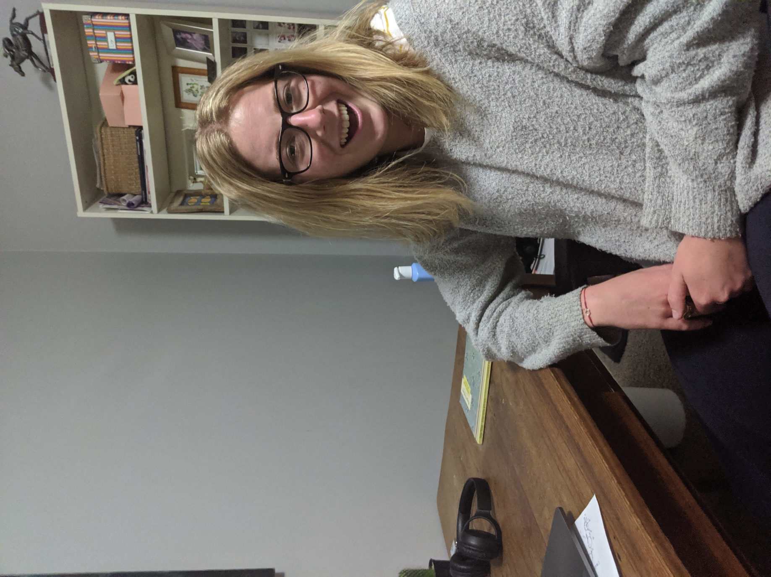

(Photos taken before and during survey because mock-up was on phone and I don’t have another phone to take photos – bitch aint rich).